BIM User Guide: September 2021
ACO Oleolift-C

User Guide for Autodesk Revit files

ACO Oleolift-C Packages

ACO Oleolift-C are incorporated in a single Revit template including all types.

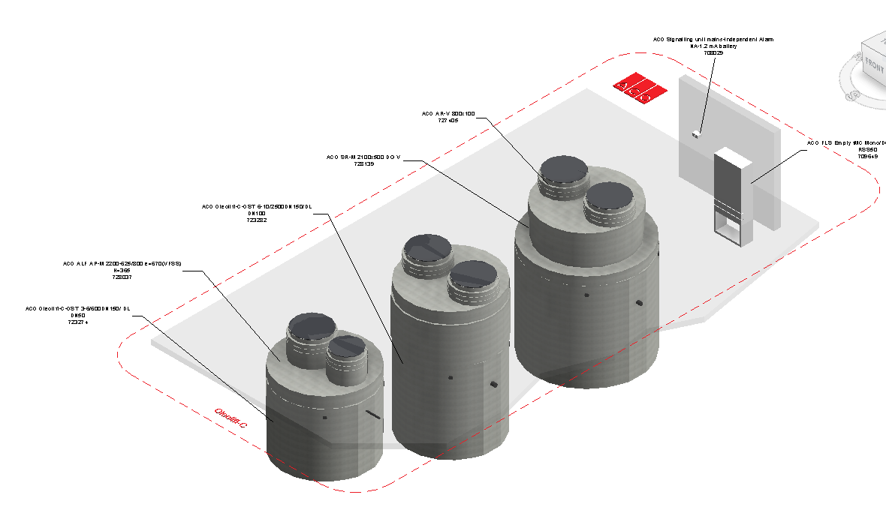
Loading ACO Oleolift-C into the project:

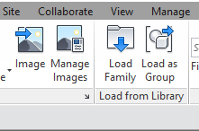
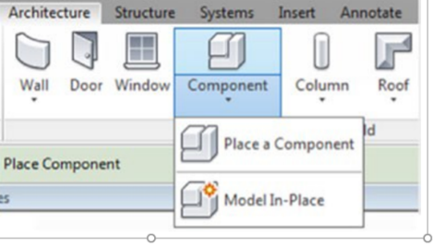
- Download the ACO Oleolift-C project file and save it to a suitable location

- Select any one of the family from ACO Oleolift-C,
load to your project

- Navigate to the “Insert” icon on the Revit ribbon and click “Load Family”

- The file can now be placed into your project. Navigate to the “Architecture/Component” icons on the Revit ribbon and click “Place a Component”

Placing of families
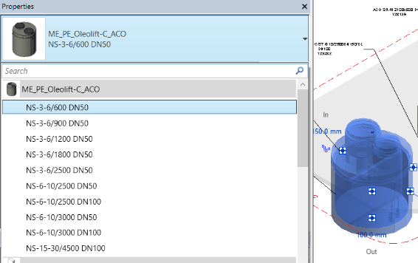
- Click on the model – At properties tool bar, it will display family name and types.

- Every family consists of different types, the user has to select the appropriate family type from the “Properties” drop down menu.

- Selection of Bearing rings and shaft rings as well as the accessories
from the tick and dropdown list available
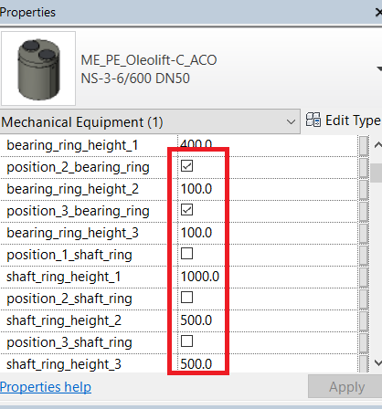

Material Library:
The ACO Oleolift-C files contain materials that are already pre-loaded into the components. When loading the ACO Oleolift-C files into your project the pre-loaded materials will automatically transfer through.

Schedules and quantities:

The information such as article number, GTIN data, weight, installation guidelines within the parameters is stored as “shared Parameters” so can easily be appeared when creating a schedule and quantities in the project environment.

