BIM User Guide: March 2022
ACO Multitop Inlet Grate

User Guide for Autodesk Revit files

ACO Multitop Inlet Grate Package
Multitop inlet grate is incorporated in a single Revit template along with its accessories.This template includes two families available with ventilation only and classified based on load class C 250 and D 400 as shown below;
- PF_CI_WPB_frame BEGU_grating cast iron_C 250
- PF_CI_WPB_frame BEGU_grating cast iron_D 400
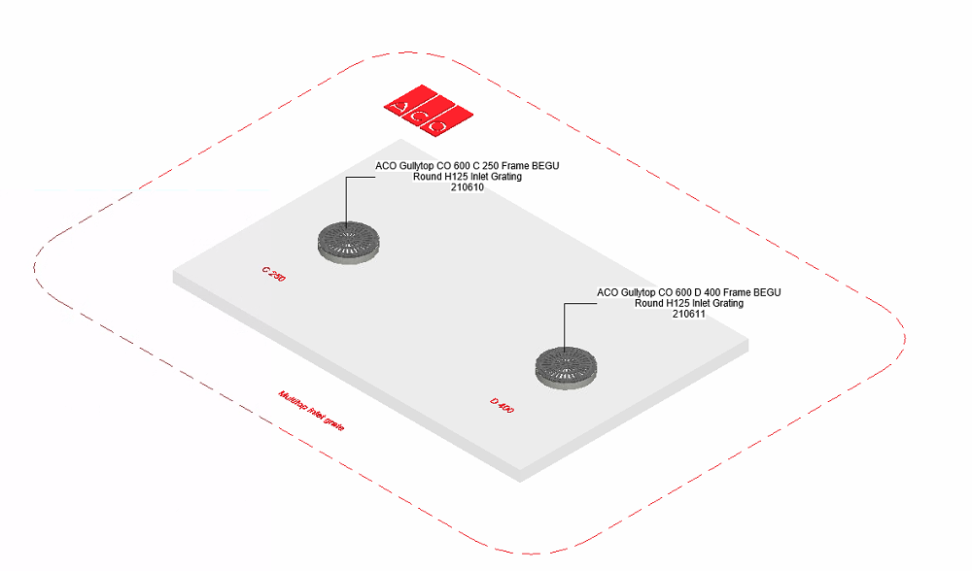

The family types are further classified based on clear opening, material and height as shown;

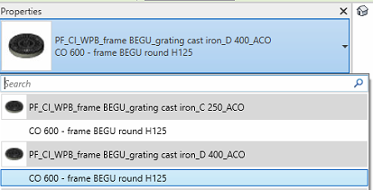

The family is available with ventilation only

Loading ACO Multitop Inlet Grate into the project:
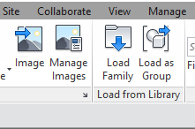
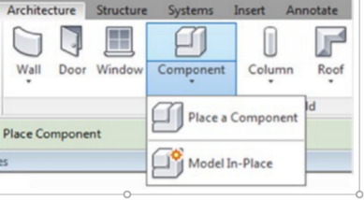
- Download the Multitop inlet grate project file and save it to a suitable location

- Select any one of the family from Multitop inlet grate and
load to your project

- Navigate to the “Insert” icon on the Revit ribbon and click “Load Family”

- The file can now be placed into your project. Navigate to the “Architecture/Component” icons on the Revit ribbon and click “Place a Component”

Placing of families

- Click on the model – At properties tool bar, it will display family name and types.

- It consists of two family one family type each, the user has to select the family type from the “Properties” drop down menu.
.
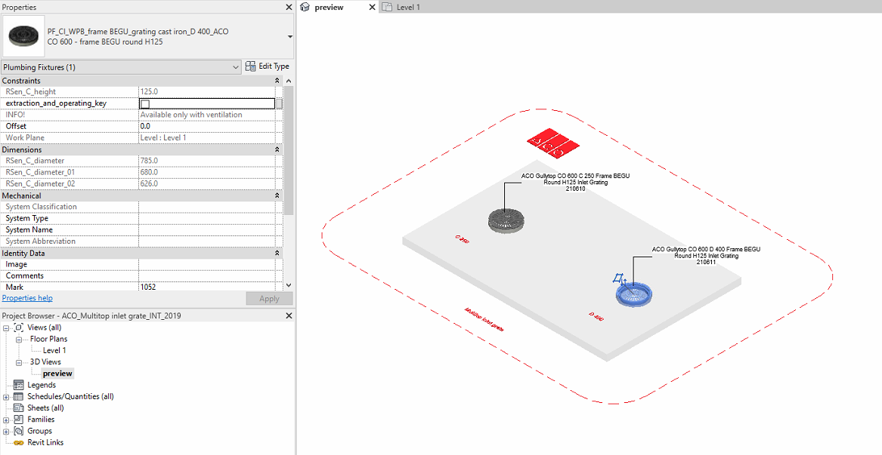

Workplane Based Families

The families are work plane-based families so they can be placed in uniform and sloped surface of road as shown below

Selection of Accessories:

Click on the model – At properties tool bar, it will display list of accessories such as access aid, extraction and operating key and funnel. Information will popup as text as it is available with ventilation only.User can select by click the list as shown below
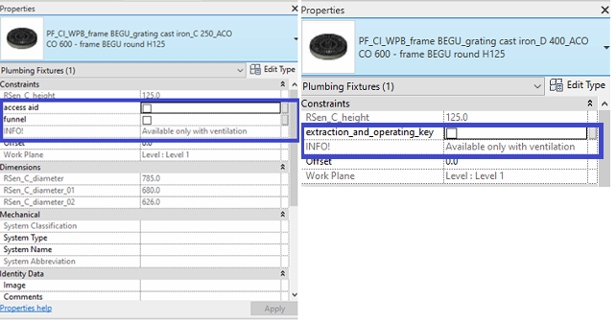

Material Library:
The ACO Multitop inlet grate file contains materials that are already pre-loaded into the components. When loading the ACO Multitop inlet grate file into your project the pre-loaded materials will automatically transfer through.

Schedules and quantities:

The information such as article number, GTIN data, weight, installation guidelines within the parameters is stored as “Shared Parameters” with LOD 400 so it can easily appear when creating a schedule and quantities in the project environment as follows

