BIM User Guide: March 2022
ACO Multitop gullytop

User Guide for Autodesk Revit files

ACO Multitop gullytop Package
Multitop gullytop is incorporated in a single Revit template along with accessories.
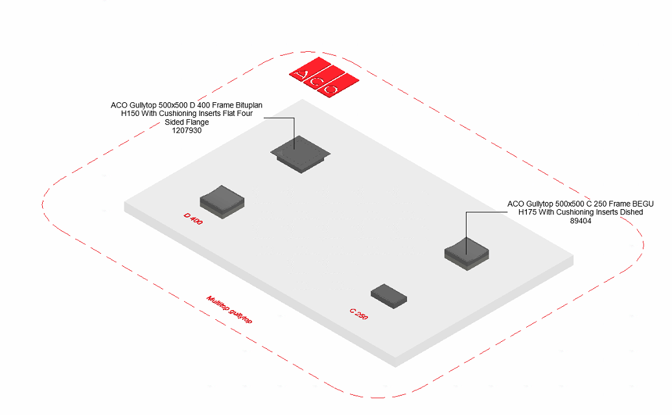
This template includes two families based on load class C 250 and D 400. The family types are further classified based on Clear Opening, material and height as shown;
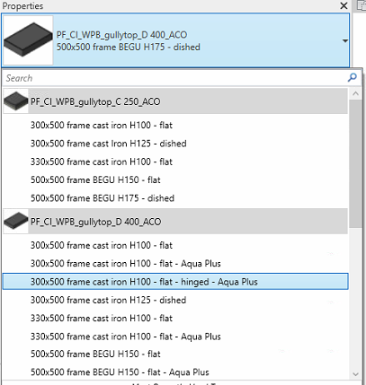

Loading ACO Multitop gullytop into the project:
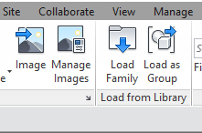
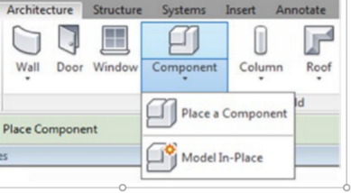
- Download the Multitop gullytop project file and save it to a suitable location

- Select any one of the family from Multitop gullytop and
load to your project

- Navigate to the “Insert” icon on the Revit ribbon and click “Load Family”

- The file can now be placed into your project. Navigate to the “Architecture/Component” icons on the Revit ribbon and click “Place a Component”

Placing of families

- Click on the model – At properties tool bar, it will display family name and types.

- It consists of two families and different family type each, the user has to select the family type from the “Properties” drop down menu.
.
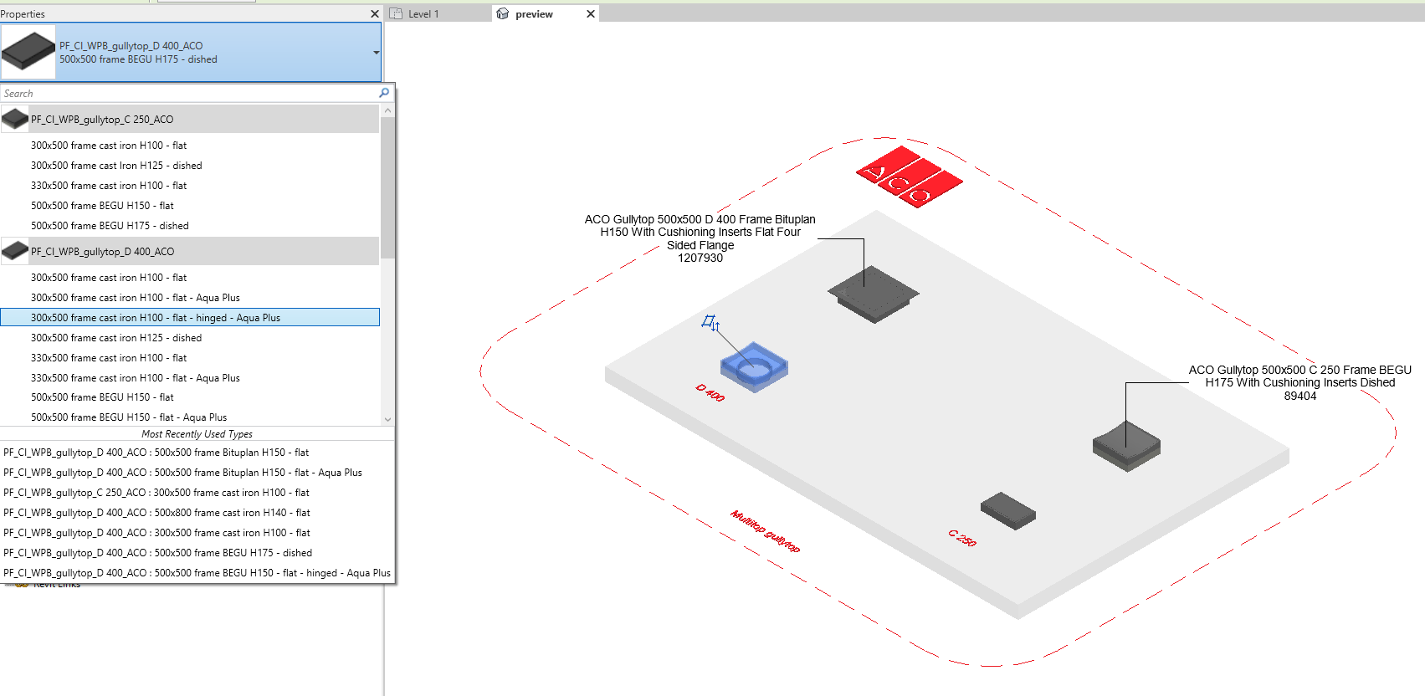
- Selection of Flange
The family has 4 family types which has an option of two sided flange and four sided flange which is named as follows;
- 500x500 frame Bituplan H150 - flat - Aqua Plus
- 500x500 frame Bituplan H150 - flat
By selecting the tick option in the PropertiesConstraints tab the user can switch over to required no. of flange side.
- Selection of Variable Height of Frame
The family types mentioned above have the variable height option. The user can enter the height by going to PropertiesConstraints tab
Minimum Hight 150mm
Maximum Height210mm

- Suppose if the user selects the height within the specified limit then the family will work as per entered height.
- Suppose if the user selects the height greater than the maximum value then by default irrespective of height entered it will be locked to maximum limit of height.
- Suppose if the user selects the height lesser than the minimum value then by default irrespective of height entered it will be locked to minimum limit of height.

Workplane Based Families

The families are work plane-based families so they can be placed in uniform and sloped surface of road as shown below
Selection of Accessories:

Click on the model – At properties tool bar, it will display list of accessories such as built in formwork, closing plates,extraction and operating key, odor trap. User can select by click the list as shown below
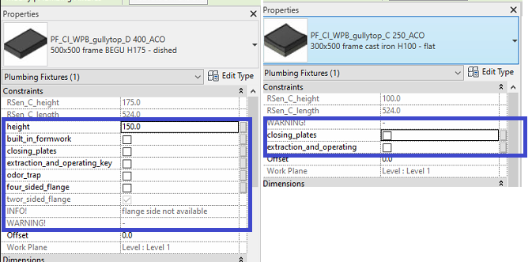

Material Library:

The ACO Multitop gullytop file contains materials that are already pre-loaded into the components. When loading the ACO Multitop gullytop file into your project the pre-loaded materials will automatically transfer through.

Schedules and quantities:

The information such as article number, GTIN data, weight, installation guidelines within the parameters is stored as “Shared Parameters” with LOD 400 so it can easily appear when creating a schedule and quantities in the project environment as follows

