BIM User Guide: March 2022
ACO Combipoint Standard Gullytop

User Guide for Autodesk Revit files

ACO Combipoint Standard Gullytop Package
Combipoint standard gullytop is incorporated in a single Revit template along with accessories. This template includes two gullytop standard families based on load class C 250 and D 400
- PF_CI_WPB_gullytop_C 250
- PF_CI_WPB_gullytop_D 400
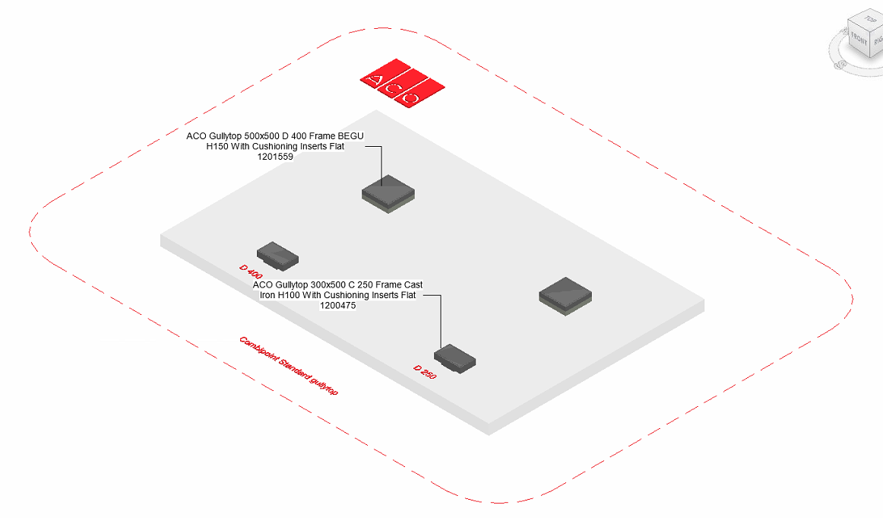
The family types are further classified based on size,material,height and shape as follows;

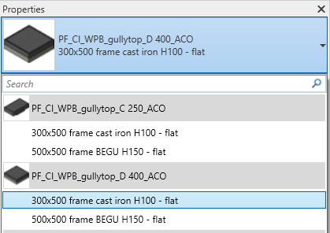

Loading ACO Combipoint standard gullytop into the project:
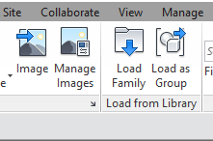
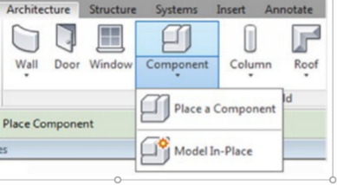
- Download the ACO Combipoint standard gullytop project file and save it to a suitable location

- Select any one of the family from ACO Combipoint standard gullytop and
load to your project

- Navigate to the “Insert” icon on the Revit ribbon and click “Load Family”

- The file can now be placed into your project. Navigate to the “Architecture/Component” icons on the Revit ribbon and click “Place a Component”

Placing of families

- Click on the model – At properties tool bar, it will display family name and types.

- Two families consists of different family types, the user has to select the appropriate family type from the “Properties” drop down menu.
.
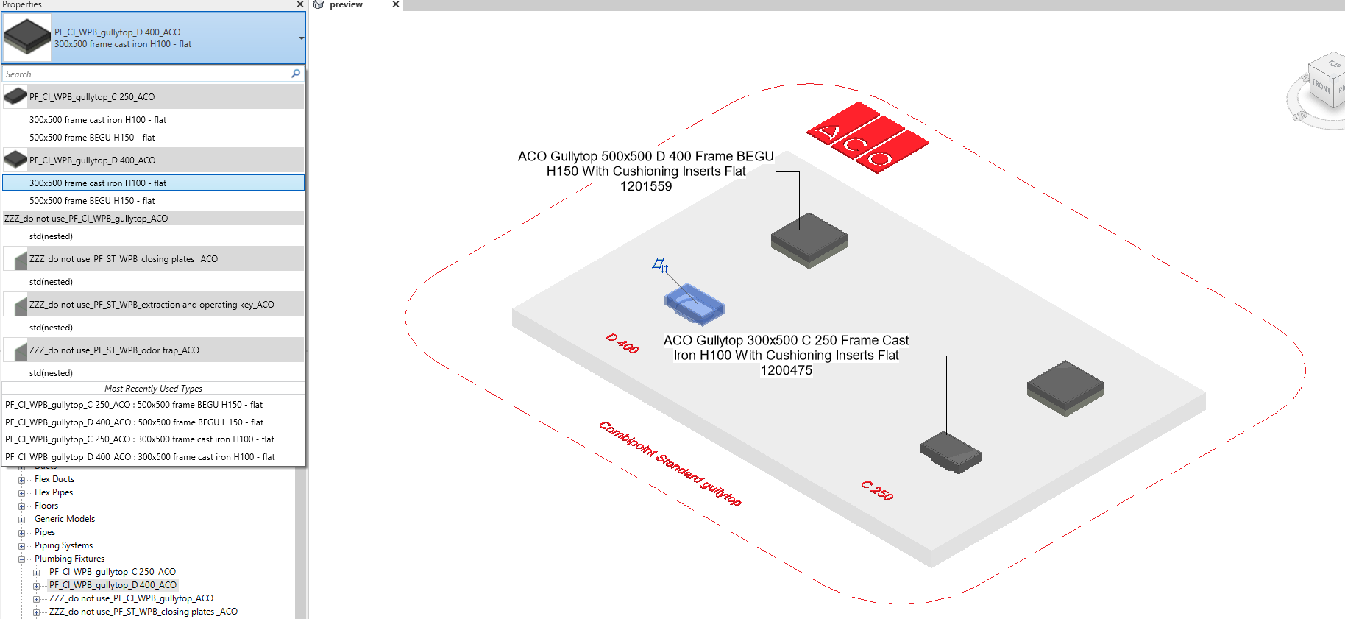

Workplane Based Families
The families are work plane-based families so they can be placed in uniform and sloped surface of road as shown below

Selection of Accessories:

Click on the model – At properties tool bar, it will display list of accessories such as closing plates, extraction and operating key and odor trap. User can select by click the list as shown below
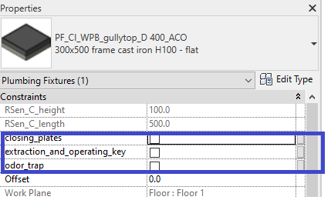

Material Library:
The ACO Combipoint standard gullytop file contain materials that are already pre-loaded into the components. When loading the ACO Combipoint standard gullytop file into your project the pre-loaded materials will automatically transfer through.

Schedules and quantities:

The information such as article number, GTIN data, weight, installation guidelines within the parameters is stored as “Shared Parameters” with LOD 400 so it can easily appear when creating a schedule and quantities in the project environment as follows

