BIM User Guide: June 2022
ACO Profiline Free

User Guide for Autodesk Revit files

ACO Profiline Free Package
ACO Profiline Free is incorporated in a single Revit template along with its accessories. This template includes three families as assemblies, one family for sewer and six nested families as shown below;
- Main Assembly Families:
- PF_ST_WPB_Profiline free channel with drain slots_ACO
- PF_ST_WPB_Profiline free channel with socket_ACO
- PF_ST_WPB_Profiline free compact channel_ACO
- PF_ST_WPB_Profiline free branch sewer_ACO
- Nested Families :
- ZZZ_do not use_PF_ST_WPB_Profiline free branch sewer connector_ACO
- ZZZ_do not use_PF_ST_WPB_Profiline free end plate left_ACO
- ZZZ_do not use_PF_ST_WPB_Profiline free end plate right_ACO
- ZZZ_do not use_PF_ST_WPB_Profiline free seal_ACO
- ZZZ_do not use_PF_ST_WPB_Profiline free gratings_ACO
- ZZZ_do not use_PF_ST_WPB_Profiline free gratings_ACO

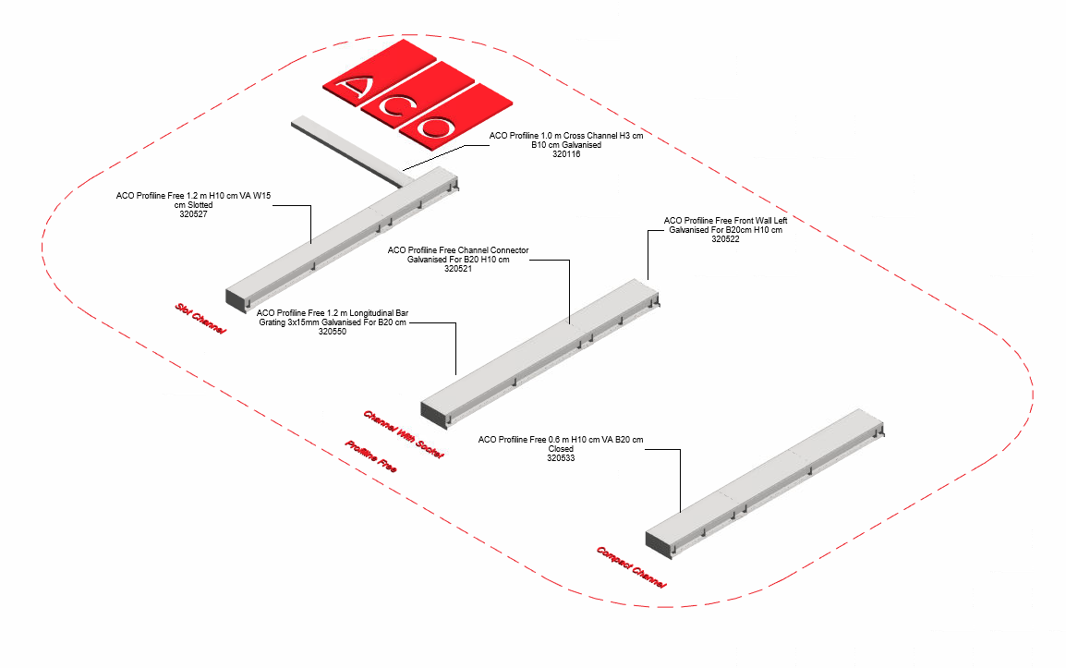

The family types are further classified based channel width and material as shown below;

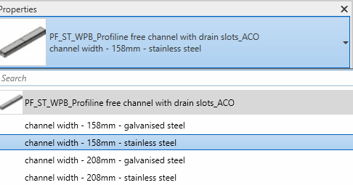

Loading ACO Profiline Free into the project:
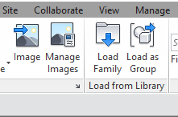
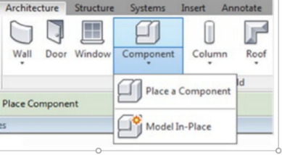
- Download the ACO Profiline Free project file and save it to a suitable location

- Select any one of the family from ACO Profiline Free
and load to your project

- Navigate to the “Insert” icon on the Revit ribbon and click “Load Family”

- The file can now be placed into your project. Navigate to the “Architecture/Component” icons on the Revit ribbon and click “Place a Component”

Placing of families

- Click on the model – At properties tool bar, it will display family name and types.

- It consists of three families and four family types, the user has to select the family type from the “Properties” drop down menu.

- PF_ST_WPB_Profiline free channel with drain slots_ACO

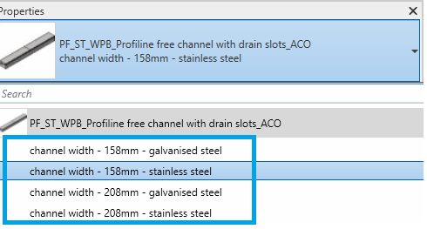

The user has to select the required family type in the drop down as shown above
Note: Similarly,the other families will work as the above Profiline free channel with drain slots

Arrangement of ‘N’ No. of families in the project
If the user wishes to place ‘n’ no. of families in the project ,then following steps needs to be followed;
- Go to Project Brower Floor Plan Level
- Place the required family PropertiesConstraints tab
- Right Click on the family as shownCreate Similar
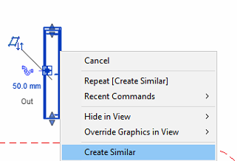
Note: By dragging the arrow the user can select the length in level plan

- All the families are work plane-based families, if needed they can be placed on sloped surfaces as well.

- Place the other family to the snapping point as shown below

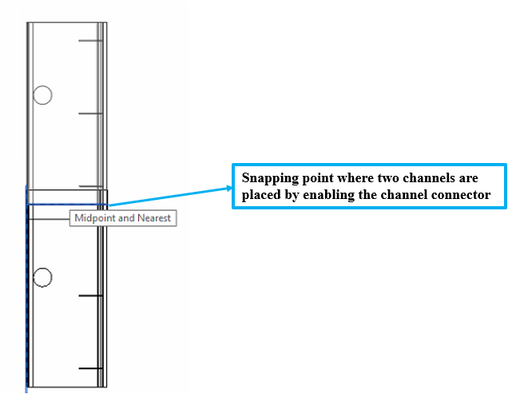

- Profiline Free Template is available both in International Version and German Version

Functionality of Profiline free channel with drain slots family

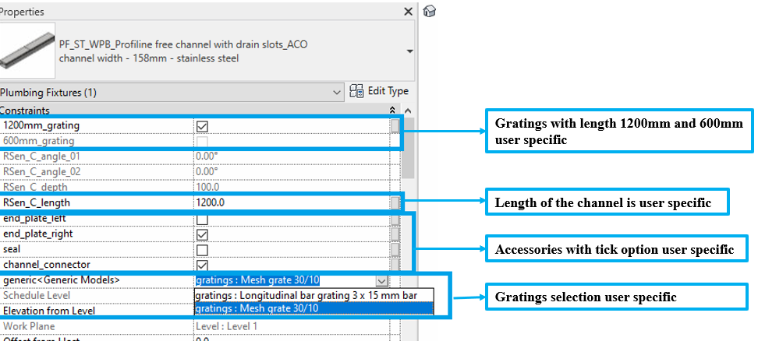

- Selection of Length:
- If the user selects the RSen_C_length=<600mm ,then even if the user checks 1200mm grating, by default 600mm gratings will be displayed in the BOM.
- If the user selects the RSen_C_length>601mm ,then if the user checks 1200mm grating 1 no. of 1200mm gratings will be displayed, if the user checks 600mm gratings then 2 No’s of 600mm gratings will be displayed in the BOM.
- Based on the RSen_C_length the article no. will change(if the user enters RSen_C_length=<600mm,then the article no. assigned to 600mm channel will appear in BOM, if the user enters RSen_C_length>600mm,then the article no. assigned to 1200mm channel will appear in BOM.
- Selection of Gratings:
- Gratings can be selected from the generic container as per user requirement.
- There are two gratings ;
- Longitudinal bar grating 3x15 mm bar
- Mesh grate 30/10

- Selection of Accessories:
Click on the model – At properties tool bar, it will display list of accessories such as End Plate Left , End Plate Right and Channel connector. User can select by click the list as shown below ;

Note: If the Channel connector and End Plate Left both are checked ,then by default only Channel connector will be enabled.

Material Library:
The ACO Profiline free file contains materials that are already pre-loaded into the components. When loading the ACO Profiline free file into your project the pre-loaded materials will automatically transfer through.

Schedules and quantities:

The information such as article number, GTIN data, weight, installation guidelines within the parameters is stored as “Shared Parameters” with LOD 400 so it can easily appear when creating a schedule and quantities in the project environment as follows;

